CS 385 – FINAL REPORT

RACHAEL GRABOWSKI & MICHAEL LANG

# INSTRUCTION SET

|  |  |  |  |
| --- | --- | --- | --- |
| Instruction | OP Code | Instruction | OP Code |
| add | 0000 | sw | 0110 |
| sub | 0001 | slt | 0111 |
| and | 0010 | beq | 1000 |
| or | 0011 | bne | 1001 |
| addi | 0100 | sll | 1010 |
| lw | 0101 | srl | 1011 |

Our implementation of a 16-bit mini pipelined MIPS machine (using gate modeling and behavioral modeling in Verilog) includes the following instructions: add, sub, and, or, addi, lw, sw, slt, beq, bne, sll, srl (see the table above for corresponding OP codes).

|  |  |  |  |  |
| --- | --- | --- | --- | --- |
| R-Format | | | | |
| OP | RS | RT | RD | Unused |
| 4 | 2 | 2 | 2 | 6 |

|  |  |  |  |
| --- | --- | --- | --- |
| I-Format | | | |
| OP | RS | RT | Address/Value |
| 4 | 2 | 2 | 8 |

# Major Component Descriptions

## Instruction Memory

The instruction memory is represented by our input.hex file (see “input.hex” below)

## ALU

The ALU is a 16-bit ALU comprised of four 4-bit ALUs. It is capable of detecting overflow and zero.

## Register File

Register r0 is static 0 (it cannot change or be changed). The register file is 4-word by 16-bits-per-word.

## Control Unit

The mainCtrl unit takes IFID_InstrMem[15:12] as input, and outputs a control signal to the IDEX register. The control options are: RegDst, BEQ, BNE, MemToReg, MemWrite, ALUsrc, RegWrite, SLL, SRL, and ALUctl.

## input.hex

The input.hex file is how we loaded our code into our program, instead of hard-coding our testing instructions. This made it very easy to swap between different sets of instructions for testing at various points in the project. MIPS ASM instructions were converted into binary, and those binary instructions were then converted into hex instructions. Those hex instructions were then read by the CPU module into instruction memory.

# DIAGRAM

Diagram is best viewed at 250% or larger

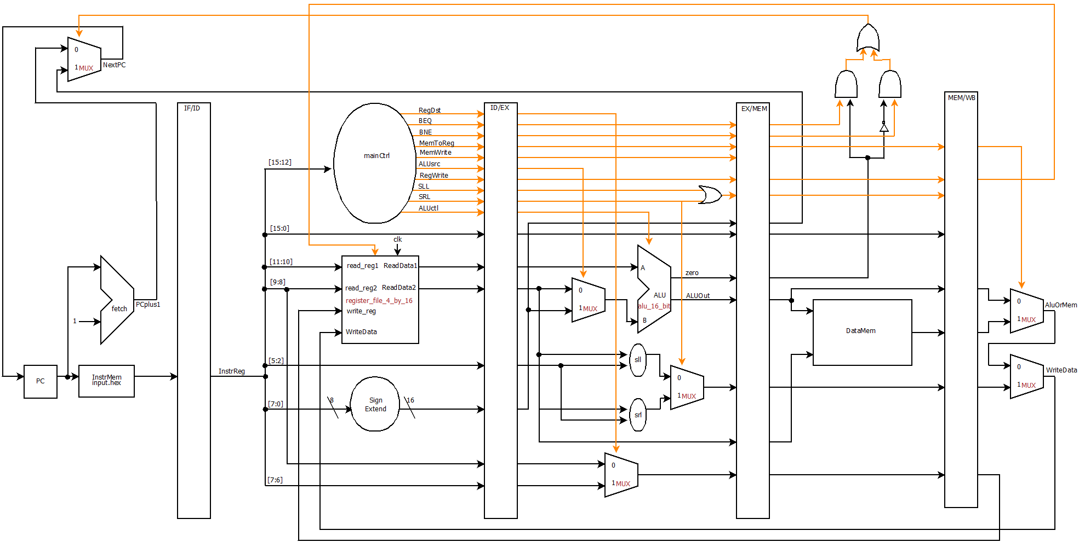

# VERILOG SOURGE CODE

## module alu_1_bit(result, c_out, a, b, less, c_in, op);

input a, b;

input less;

input c_in;

input [2:0] op;

output result, c_out;

wire m, n, p, q, r;

not g1(m, b);

mux_2_to_1 mux1(n, b, m, op[2]);

and g2(p, a, n);

or g3(q, a, n);

full_adder fa(r, c_out, a, n, c_in);

mux_4_to_1 mux2(result, p, q, r, less, op[1:0]);

endmodule

## module alu_1_bit_msb(result, overflow, set, c_out, a, b, less, c_in, op);

input a, b;

input less;

input c_in;

input [2:0] op;

output result, overflow, set, c_out;

wire m, n, p, q;

not g1(m, b);

mux_2_to_1 mux1(n, b, m, op[2]);

and g2(p, a, n);

or g3(q, a, n);

full_adder fa(set, c_out, a, n, c_in);

mux_4_to_1 mux2(result, p, q, set, less, op[1:0]);

xor g4(overflow, c_out, c_in);

endmodule

## module alu_4_bit(result, zero, c_out, a, b, less, c_in, op);

input [3:0] a;

input [3:0] b;

input less;

input c_in;

input [2:0] op;

output [3:0] result;

output zero, c_out;

wire p, q, r, s, t;

alu_1_bit alu_0(result[0], p, a[0], b[0], less, c_in, op),

alu_1(result[1], q, a[1], b[1], 0, p, op),

alu_2(result[2], r, a[2], b[2], 0, q, op),

alu_3(result[3], c_out, a[3], b[3], 0, r, op);

or g1(s, result[0], result[1]),

g2(t, result[2], result[3]);

nor g3(zero, s, t);

endmodule

## module alu_4_bit_last(result, overflow, set, zero, c_out, a, b, c_in, op);

input [3:0] a;

input [3:0] b;

input c_in;

input [2:0] op;

output [3:0] result;

output overflow, set, zero, c_out;

wire p, q, r, s, t;

alu_1_bit alu_0(result[0], p, a[0], b[0], 0, c_in, op),

alu_1(result[1], q, a[1], b[1], 0, p, op),

alu_2(result[2], r, a[2], b[2], 0, q, op);

alu_1_bit_msb alu_3(result[3], overflow, set, c_out, a[3], b[3], 0, r, op);

or g1(s, result[0], result[1]),

g2(t, result[2], result[3]);

nor g3(zero, s, t);

endmodule

## module alu_16_bit(result, overflow, zero, c_out, a, b, op);

input [15:0] a;

input [15:0] b;

input [2:0] op;

output [15:0] result;

output overflow, zero, c_out;

wire p, q, r, s, t, u, v, w, x;

wire less;

alu_4_bit alu_0(result[3:0], s, p, a[3:0], b[3:0], less, op[2], op),

alu_1(result[7:4], t, q, a[7:4], b[7:4], 0, p, op),

alu_2(result[11:8], u, r, a[11:8], b[11:8], 0, q, op);

alu_4_bit_last alu_3(result[15:12], overflow, less, v, c_out, a[15:12], b[15:12], r, op);

and g1(w, s, t),

g2(x, u, v),

g3(zero, w, x);

endmodule

## module d_flip_flop(D,CLK,Q);

input D,CLK;

output Q;

wire CLK1, Y;

not not1 (CLK1,CLK);

d_latch D1(D,CLK, Y),

D2(Y,CLK1,Q);

endmodule

## module d_latch(D,C,Q);

input D,C;

output Q;

wire x,y,D1,Q1;

nand nand1 (x,D, C),

nand2 (y,D1,C),

nand3 (Q,x,Q1),

nand4 (Q1,y,Q);

not not1 (D1,D);

endmodule

## module decoder_2_to_4(out, sel);

input [1:0] sel;

output [3:0] out;

wire not_sel0, not_sel1;

not n0(not_sel0, sel[0]),

n1(not_sel1, sel[1]);

and a0(out[0], not_sel0, not_sel1),

a1(out[1], sel[0], not_sel1),

a2(out[2], not_sel0, sel[1]),

a3(out[3], sel[0], sel[1]);

endmodule

## module half_adder(sum, c_out, a, b);

input a, b;

output sum, c_out;

xor g1 (sum, a, b);

and g2 (c_out, a, b);

endmodule

## module full_adder(sum, c_out, a, b, c_in);

input a, b, c_in;

output sum, c_out;

wire p, q, r;

half_adder ha1(p, q, a, b),

ha2(sum, r, p, c_in);

or g1(c_out, r, q);

endmodule

## module mux_2_to_1(x, a, b, sel);

input a, b, sel;

output x;

wire p, q, r;

not g1 (p, sel);

and g2 (q, a, p),

g3 (r, b, sel);

or g4 (x, q, r);

endmodule

## module mux_4_to_1(x, a, b, c, d, sel);

input a, b, c, d;

input [1:0] sel;

output x;

wire p, q;

mux_2_to_1 mux1(p, a, b, sel[0]),

mux2(q, c, d, sel[0]),

mux3(x, p, q, sel[1]);

endmodule

## module mux_4_to_2(x, a, b, sel);

input [1:0] a, b;

input sel;

output [1:0] x;

mux_2_to_1 mux1(x[0], a[0], b[0], sel),

mux2(x[1], a[1], b[1], sel);

endmodule

## module mux_32_to_16(x, a, b, sel);

input [15:0] a, b;

input sel;

output [15:0] x;

mux_2_to_1 m0(x[0], a[0], b[0], sel),

m1(x[1], a[1], b[1], sel),

m2(x[2], a[2], b[2], sel),

m3(x[3], a[3], b[3], sel),

m4(x[4], a[4], b[4], sel),

m5(x[5], a[5], b[5], sel),

m6(x[6], a[6], b[6], sel),

m7(x[7], a[7], b[7], sel),

m8(x[8], a[8], b[8], sel),

m9(x[9], a[9], b[9], sel),

m10(x[10], a[10], b[10], sel),

m11(x[11], a[11], b[11], sel),

m12(x[12], a[12], b[12], sel),

m13(x[13], a[13], b[13], sel),

m14(x[14], a[14], b[14], sel),

m15(x[15], a[15], b[15], sel);

endmodule

## module mux_64_to_16(x, a, b, c, d, sel);

input [15:0] a, b, c, d;

input [1:0] sel;

output [15:0] x;

mux_4_to_1 m0(x[0], a[0], b[0], c[0], d[0], sel),

m1(x[1], a[1], b[1], c[1], d[1], sel),

m2(x[2], a[2], b[2], c[2], d[2], sel),

m3(x[3], a[3], b[3], c[3], d[3], sel),

m4(x[4], a[4], b[4], c[4], d[4], sel),

m5(x[5], a[5], b[5], c[5], d[5], sel),

m6(x[6], a[6], b[6], c[6], d[6], sel),

m7(x[7], a[7], b[7], c[7], d[7], sel),

m8(x[8], a[8], b[8], c[8], d[8], sel),

m9(x[9], a[9], b[9], c[9], d[9], sel),

m10(x[10], a[10], b[10], c[10], d[10], sel),

m11(x[11], a[11], b[11], c[11], d[11], sel),

m12(x[12], a[12], b[12], c[12], d[12], sel),

m13(x[13], a[13], b[13], c[13], d[13], sel),

m14(x[14], a[14], b[14], c[14], d[14], sel),

m15(x[15], a[15], b[15], c[15], d[15], sel);

endmodule

module register_16_bit(out, in, clk);

input [15:0] in;

input clk;

output [15:0] out;

d_flip_flop d0(in[0], clk, out[0]),

d1(in[1], clk, out[1]),

d2(in[2], clk, out[2]),

d3(in[3], clk, out[3]),

d4(in[4], clk, out[4]),

d5(in[5], clk, out[5]),

d6(in[6], clk, out[6]),

d7(in[7], clk, out[7]),

d8(in[8], clk, out[8]),

d9(in[9], clk, out[9]),

d10(in[10], clk, out[10]),

d11(in[11], clk, out[11]),

d12(in[12], clk, out[12]),

d13(in[13], clk, out[13]),

d14(in[14], clk, out[14]),

d15(in[15], clk, out[15]);

endmodule

module register_file_4_by_16(read_data1, read_data2, read_reg1, read_reg2, write_reg, write_data, reg_write, clk);

input [1:0] read_reg1, read_reg2, write_reg;

input [15:0] write_data;

input reg_write, clk;

output [15:0] read_data1, read_data2;

wire [3:0] w, c;

wire p;

wire [15:0] q1, q2, q3;

decoder_2_to_4 dec(w, write_reg);

and g1(p, reg_write, clk),

g2(c[1], p, w[1]),

g3(c[2], p, w[2]),

g4(c[3], p, w[3]);

register_16_bit r1(q1, write_data, c[1]),

r2(q2, write_data, c[2]),

r3(q3, write_data, c[3]);

mux_64_to_16 m1(read_data1, 0, q1, q2, q3, read_reg1),

m2(read_data2, 0, q1, q2, q3, read_reg2);

endmodule

## module shift_left_logical(out, in, shift_amount);

input [15:0] in;

input [3:0] shift_amount;

output [15:0] out;

wire [15:0] p, q, r;

mux_32_to_16 mux1(p, in[15:0], {in[7:0],8'b0}, shift_amount[3]),

mux2(q, p, {p[11:0],4'b0}, shift_amount[2]),

mux3(r, q, {q[13:0],2'b0}, shift_amount[1]),

mux4(out, r, {r[14:0],1'b0}, shift_amount[0]);

endmodule

## module shift_right_logical(out, in, shift_amount);

input [15:0] in;

input [3:0] shift_amount;

output [15:0] out;

wire [15:0] p, q, r;

mux_32_to_16 mux1(p, in[15:0], {8'b0,in[15:8]}, shift_amount[3]),

mux2(q, p, {4'b0,p[15:4]}, shift_amount[2]),

mux3(r, q, {2'b0,q[15:2]}, shift_amount[1]),

mux4(out, r, {1'b0,r[15:1]}, shift_amount[0]);

endmodule

## module CPU (clock, PC, IFID_InstrReg, IDEX_InstrReg, EXMEM_InstrReg, MEMWB_InstrReg, WriteData);

input clock;

output [15:0] PC, WriteData, IFID_InstrReg, IDEX_InstrReg, EXMEM_InstrReg, MEMWB_InstrReg;

// IF

wire [15:0] NextPC, PCplus1;

reg [15:0] PC, IFID_InstrReg;

reg [15:0] InstrMem[0:511];

alu_16_bit fetch(PCplus1, unused1, unused2, unused3, PC, 1, 3'b010);

mux_32_to_16 mux1(NextPC, PCplus1, EXMEM_SignExtend, PCsrc);

// Read hex data from text file into InstrMem

initial begin

$readmemh("input4.hex", InstrMem);

DataMem[0] = 16'h400;

DataMem[1] = 16'hfad;

end

// ID

reg [15:0] IDEX_InstrReg;

wire [11:0] control;

reg IDEX_RegDst, IDEX_BEQ, IDEX_BNE, IDEX_MemToReg, IDEX_MemWrite, IDEX_ALUsrc, IDEX_RegWrite, IDEX_SLL, IDEX_SRL;

reg [2:0] IDEX_ALUctl;

wire [15:0] ReadData1, ReadData2, SignExtend, WriteData;

reg [15:0] IDEX_ReadData1, IDEX_ReadData2, IDEX_SignExtend;

reg [1:0] IDEX_rt, IDEX_rd;

reg [3:0] IDEX_shamt;

register_file_4_by_16 regFile(ReadData1, ReadData2, IFID_InstrReg[11:10], IFID_InstrReg[9:8], MEMWB_WriteReg, WriteData, MEMWB_RegWrite, clock);

main_control mainCtrl(IFID_InstrReg[15:12], control);

assign SignExtend = {{8{IFID_InstrReg[7]}},IFID_InstrReg[7:0]}; // sign extension

// EX

wire [15:0] B, ALUout, ShiftLOut, ShiftROut, Shifted;

wire [1:0] WriteReg;

wire Zero, ShiftToReg;

reg EXMEM_RegWrite, EXMEM_MemToReg;

reg EXMEM_MemWrite, EXMEM_BEQ, EXMEM_BNE, EXMEM_ShiftToReg;

reg EXMEM_Zero;

reg [15:0] EXMEM_SignExtend, EXMEM_ALUout, EXMEM_ReadData2, EXMEM_Shifted;

reg [15:0] EXMEM_InstrReg;

reg [1:0] EXMEM_WriteReg;

alu_16_bit ex(ALUout, unused4, Zero, unused5, IDEX_ReadData1, B, IDEX_ALUctl);

mux_4_to_2 mux2(WriteReg, IDEX_rt, IDEX_rd, IDEX_RegDst);

mux_32_to_16 mux3(B, IDEX_ReadData2, IDEX_SignExtend, IDEX_ALUsrc);

shift_left_logical sll(ShiftLOut, IDEX_ReadData2, IDEX_shamt);

shift_right_logical srl(ShiftROut, IDEX_ReadData2, IDEX_shamt);

mux_32_to_16 mux4(Shifted, ShiftLOut, ShiftROut, IDEX_SRL);

or g1(ShiftToReg, IDEX_SLL, IDEX_SRL);

// MEM

wire [15:0] MemOut, AluOrMem;

wire NotZero, ne, eq, PCsrc;

reg MEMWB_RegWrite, MEMWB_MemToReg, MEMWB_ShiftToReg;

reg [15:0] DataMem[0:511];

reg [15:0] MEMWB_MemOut, MEMWB_ALUout, MEMWB_Shifted;

reg [15:0] MEMWB_InstrReg;

reg [1:0] MEMWB_WriteReg;

not g2(NotZero, EXMEM_Zero);

and g3(ne, EXMEM_BNE, NotZero),

g4(eq, EXMEM_BEQ, EXMEM_Zero);

or g5(PCsrc, ne, eq);

assign MemOut = DataMem[EXMEM_ALUout];

always @(negedge clock) begin

if(EXMEM_MemWrite)

DataMem[EXMEM_ALUout] <= EXMEM_ReadData2;

end

// WB

mux_32_to_16 mux5(AluOrMem, MEMWB_ALUout, MEMWB_MemOut, MEMWB_MemToReg);

mux_32_to_16 mux6(WriteData, AluOrMem, MEMWB_Shifted, MEMWB_ShiftToReg);

initial begin

// Initialize registers

PC = 0;

IFID_InstrReg = 0;

IDEX_InstrReg = 0;

IDEX_RegDst = 0;

IDEX_BEQ = 0;

IDEX_BNE = 0;

IDEX_MemToReg = 0;

IDEX_MemWrite = 0;

IDEX_ALUsrc = 0;

IDEX_RegWrite = 0;

IDEX_SLL = 0;

IDEX_SRL = 0;

IDEX_shamt = 0;

IDEX_ALUctl = 3'b000;

IDEX_ReadData1 = 0;

IDEX_ReadData2 = 0;

IDEX_SignExtend = 0;

IDEX_rd = 0;

IDEX_rt = 0;

EXMEM_InstrReg = 0;

EXMEM_BEQ = 0;

EXMEM_BNE = 0;

EXMEM_MemToReg = 0;

EXMEM_MemWrite = 0;

EXMEM_RegWrite = 0;

EXMEM_ShiftToReg = 0;

EXMEM_ALUout = 0;

EXMEM_ReadData2 = 0;

EXMEM_SignExtend = 0;

EXMEM_Shifted = 0;

EXMEM_WriteReg = 0;

EXMEM_Zero = 0;

MEMWB_MemToReg = 0;

MEMWB_RegWrite = 0;

MEMWB_ShiftToReg = 0;

MEMWB_ALUout = 0;

MEMWB_InstrReg = 0;

MEMWB_MemOut = 0;

MEMWB_Shifted = 0;

MEMWB_WriteReg = 0;

end

always @(negedge clock) begin

// Stage 1 -- IF

IFID_InstrReg <= InstrMem[PC];

PC <= NextPC;

// Stage 2 -- ID

IDEX_InstrReg <= IFID_InstrReg;

{IDEX_RegDst, IDEX_BEQ, IDEX_BNE, IDEX_MemToReg, IDEX_MemWrite, IDEX_ALUsrc, IDEX_RegWrite, IDEX_SLL, IDEX_SRL, IDEX_ALUctl} <= control;

IDEX_ReadData1 <= ReadData1;

IDEX_ReadData2 <= ReadData2;

IDEX_SignExtend <= SignExtend;

IDEX_rt <= IFID_InstrReg[9:8];

IDEX_rd <= IFID_InstrReg[7:6];

IDEX_shamt <= IFID_InstrReg[5:2];

// Stage 3 -- EX

EXMEM_InstrReg <= IDEX_InstrReg;

EXMEM_RegWrite <= IDEX_RegWrite;

EXMEM_MemToReg <= IDEX_MemToReg;

EXMEM_ShiftToReg <= ShiftToReg;

EXMEM_BEQ <= IDEX_BEQ;

EXMEM_BNE <= IDEX_BNE;

EXMEM_MemWrite <= IDEX_MemWrite;

EXMEM_Zero <= Zero;

EXMEM_ALUout <= ALUout;

EXMEM_ReadData2 <= IDEX_ReadData2;

EXMEM_WriteReg <= WriteReg;

EXMEM_SignExtend <= IDEX_SignExtend;

EXMEM_Shifted <= Shifted;

// Stage 4 -- MEM

MEMWB_InstrReg <= EXMEM_InstrReg;

MEMWB_RegWrite <= EXMEM_RegWrite;

MEMWB_MemToReg <= EXMEM_MemToReg;

MEMWB_ShiftToReg <= EXMEM_ShiftToReg;

MEMWB_MemOut <= MemOut;

MEMWB_ALUout <= EXMEM_ALUout;

MEMWB_WriteReg <= EXMEM_WriteReg;

MEMWB_Shifted <= EXMEM_Shifted;

end

endmodule

## module main_control(Op,Control);

input [3:0] Op;

output reg [11:0] Control;

always @(Op) case (Op)

// {RegDst, BEQ, BNE, MemtoReg, MemWrite, ALUSrc, RegWrite, SLL, SRL, ALUctl[2], ALUctl[1], ALUctl[0]}

4'b0000: Control <= 12'b100000100010; // add

4'b0001: Control <= 12'b100000100110; // sub

4'b0010: Control <= 12'b100000100000; // and

4'b0011: Control <= 12'b100000100001; // or

4'b0100: Control <= 12'b000001100010; // addi

4'b0101: Control <= 12'b000111100010; // lw

4'b0110: Control <= 12'b000011000010; // sw

4'b0111: Control <= 12'b100000100111; // slt

4'b1000: Control <= 12'b010000000110; // beq

4'b1001: Control <= 12'b001000000110; // bne

4'b1010: Control <= 12'b100000110000; // sll

4'b1011: Control <= 12'b100000101000; // srl

endcase

endmodule

## module test ();

reg clock;

wire [15:0] PC, IFID_InstrReg, IDEX_InstrReg, EXMEM_InstrReg, MEMWB_InstrReg, WriteData;

CPU test_cpu(clock, PC, IFID_InstrReg, IDEX_InstrReg, EXMEM_InstrReg, MEMWB_InstrReg, WriteData);

always #1 clock = ~clock;

initial begin

$display ("time PC IFID_IR IDEX_IR EXMEM_IR MEMWB_IR WD");

$monitor ("%2d %3d %h %h %h %h %h", $time, PC, IFID_InstrReg, IDEX_InstrReg, EXMEM_InstrReg, MEMWB_InstrReg, WriteData);

clock = 1;

#80 $finish;

end

endmodule

# Testing & Results

## Testing Code

### input4.hex

5100 // lw $1, 0($0) ==> 0101000100000000

5201 // lw $2, 1($0) ==> 0101001000000001

0000 // nop ==> 0000000000000000

0000 // nop ==> 0000000000000000

0000 // nop ==> 0000000000000000

76c0 // slt $3, $1, $2 ==> 0111011011000000

0000 // nop ==> 0000000000000000

0000 // nop ==> 0000000000000000

0000 // nop ==> 0000000000000000

8c17 // beq $3, $0, 23 ==> 1000110000010111

0000 // nop ==> 0000000000000000

0000 // nop ==> 0000000000000000

0000 // nop ==> 0000000000000000

6101 // sw $1, 1($0) ==> 0110000100000001

6200 // sw $2, 0($0) ==> 0110001000000000

0000 // nop ==> 0000000000000000

0000 // nop ==> 0000000000000000

0000 // nop ==> 0000000000000000

5100 // lw $1, 0($0) ==> 0101000100000000

5201 // lw $2, 1($0) ==> 0101001000000001

0000 // nop ==> 0000000000000000

0000 // nop ==> 0000000000000000

0000 // nop ==> 0000000000000000

1640 // sub $1, $1, $2 ==> 0001011001000000

0000 // nop ==> 0000000000000000

0000 // nop ==> 0000000000000000

0000 // nop ==> 0000000000000000

a1a0 // sll $2, $1, 8 ==> 1010000110100000

0000 // nop ==> 0000000000000000

0000 // nop ==> 0000000000000000

0000 // nop ==> 0000000000000000

b2a0 // srl $2, $2, 3 ==> 1011001010100000

## Testing Results

### Screenshot

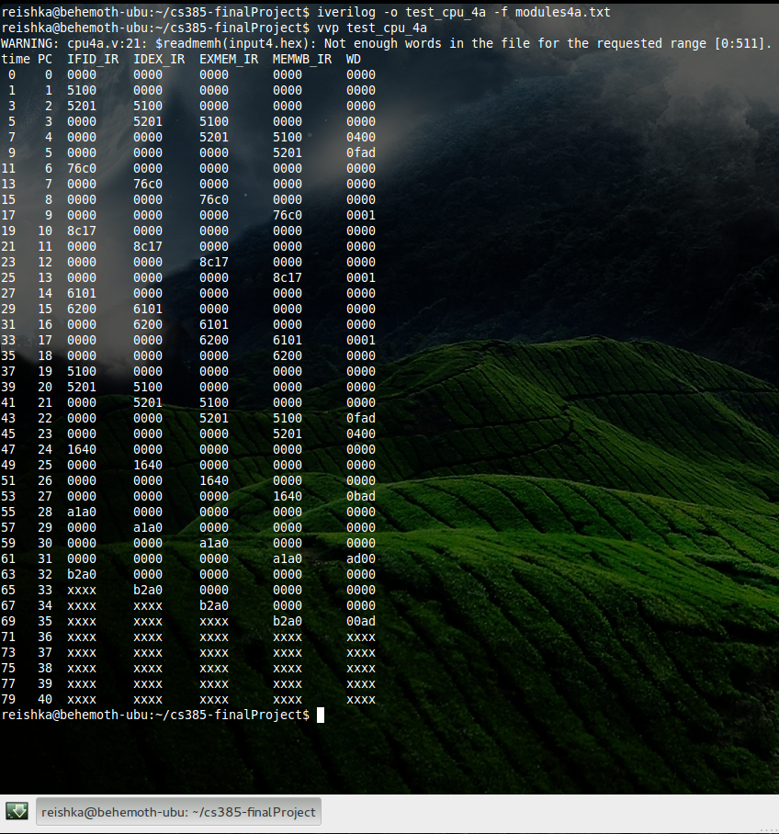

### Plaintext

reishka@behemoth-ubu:~/cs385-finalProject$ iverilog -o test_cpu_4a -f modules4a.txt

reishka@behemoth-ubu:~/cs385-finalProject$ vvp test_cpu_4a

WARNING: cpu4a.v:21: $readmemh(input4.hex): Not enough words in the file for the requested range [0:511].

time PC IFID_IR IDEX_IR EXMEM_IR MEMWB_IR WD

0 0 0000 0000 0000 0000 0000

1 1 5100 0000 0000 0000 0000

3 2 5201 5100 0000 0000 0000

5 3 0000 5201 5100 0000 0000

7 4 0000 0000 5201 5100 0400

9 5 0000 0000 0000 5201 0fad

11 6 76c0 0000 0000 0000 0000

13 7 0000 76c0 0000 0000 0000

15 8 0000 0000 76c0 0000 0000

17 9 0000 0000 0000 76c0 0001

19 10 8c17 0000 0000 0000 0000

21 11 0000 8c17 0000 0000 0000

23 12 0000 0000 8c17 0000 0000

25 13 0000 0000 0000 8c17 0001

27 14 6101 0000 0000 0000 0000

29 15 6200 6101 0000 0000 0000

31 16 0000 6200 6101 0000 0000

33 17 0000 0000 6200 6101 0001

35 18 0000 0000 0000 6200 0000

37 19 5100 0000 0000 0000 0000

39 20 5201 5100 0000 0000 0000

41 21 0000 5201 5100 0000 0000

43 22 0000 0000 5201 5100 0fad

45 23 0000 0000 0000 5201 0400

47 24 1640 0000 0000 0000 0000

49 25 0000 1640 0000 0000 0000

51 26 0000 0000 1640 0000 0000

53 27 0000 0000 0000 1640 0bad

55 28 a1a0 0000 0000 0000 0000

57 29 0000 a1a0 0000 0000 0000

59 30 0000 0000 a1a0 0000 0000

61 31 0000 0000 0000 a1a0 ad00

63 32 b2a0 0000 0000 0000 0000

65 33 xxxx b2a0 0000 0000 0000

67 34 xxxx xxxx b2a0 0000 0000

69 35 xxxx xxxx xxxx b2a0 00ad

71 36 xxxx xxxx xxxx xxxx xxxx

73 37 xxxx xxxx xxxx xxxx xxxx

75 38 xxxx xxxx xxxx xxxx xxxx

77 39 xxxx xxxx xxxx xxxx xxxx

79 40 xxxx xxxx xxxx xxxx xxxx

reishka@behemoth-ubu:~/cs385-finalProject$